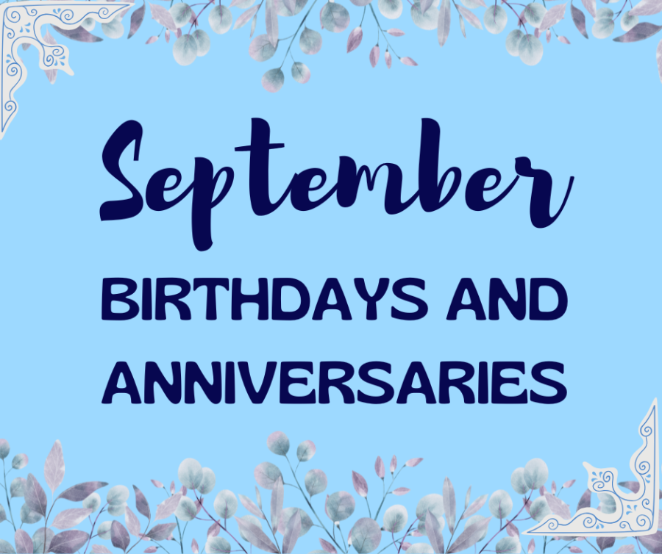
Full Name Date of Birth
Monica Smith 9/1
Karen D’Angelo 9/9

Full Name Anniversary Date
Jay & Gloria Connelley 9/10

Jeremiah 29:13 – “And you shall seek Me, & find Me, when you shall search for Me with all your heart.”



