September | 2026
Bolivar Pentecostal Church BPCHarpersFerry@gmail.com www.bpcharpersferry.com
Sunday | Monday | Tuesday | Wednesday | Thursday | Friday | Saturday
 |  | 1 | 2 | 3 | 4 | 5
 |  | Prayer Meeting 9am | Prayer Meeting 9am  Midweek Bible Study & Youth Service @ 6:30pm | Prayer Meeting 9am | Prayer Meeting 9am  Pastor Eric’s Sound Of Truth Radio 12:30am & 1:30pm
MISSIONS SUNDAY 6 | 7 | 8 | 9 | 10 | 11 | 12
PSP @ 9:30am  Sun School 10am  Sun AM Worship 11am  *NO PM WORSHIP* | *NO Prayer Meeting 9am *  Happy Labor Day | Prayer Meeting 9am  Board Meeting @ 6pm | Prayer Meeting 9am  Midweek Bible Study & Youth Service @ 6:30pm | Prayer Meeting 9am | Prayer Meeting 9am  Pastor Eric’s Sound Of Truth Radio 12:30am & 1:30pm | Special Services w/ Jim Law 10am Breakfast & Ministry
Jim Law AM 13 | 14 | 15 | *NO Prayer 16 | 17 | 18 | 19
PSP @ 9:30am  Sun School 10am  Sun AM Worship 11am  *NO PM WORSHIP* | *NO Prayer Meeting 9am* | *NO Prayer Meeting 9am*  ANNA’S HEART 6PM | Meeting 9am*  Midweek Bible Study & Youth Service @ 6:30pm | Prayer Meeting 9am | Prayer Meeting 9am  Pastor Eric’s Sound Of Truth Radio 12:30am & 1:30pm
20 | 21 | 22 | 23 | 24 | 25 | 26
PSP @ 9:30am  Sun School 10am  Sun AM Worship 11am  Sun PM Worship 6pm | Prayer Meeting 9am | Prayer Meeting 9am | Prayer Meeting 9am  Midweek Bible Study & Youth Service @ 6:30pm | Prayer Meeting 9am | Prayer Meeting 9am  Pastor Eric’s Sound Of Truth Radio 12:30am & 1:30pm
27 | 28 | 29 | Men’s Retreat NY 30
PSP @ 9:30am  Sun School 10am  Sun AM Worship 11am  Sun PM Worship 6pm | Prayer Meeting 9am | Prayer Meeting 9am | Prayer Meeting 9am  Midweek Bible Study & Youth @ 6:30pm
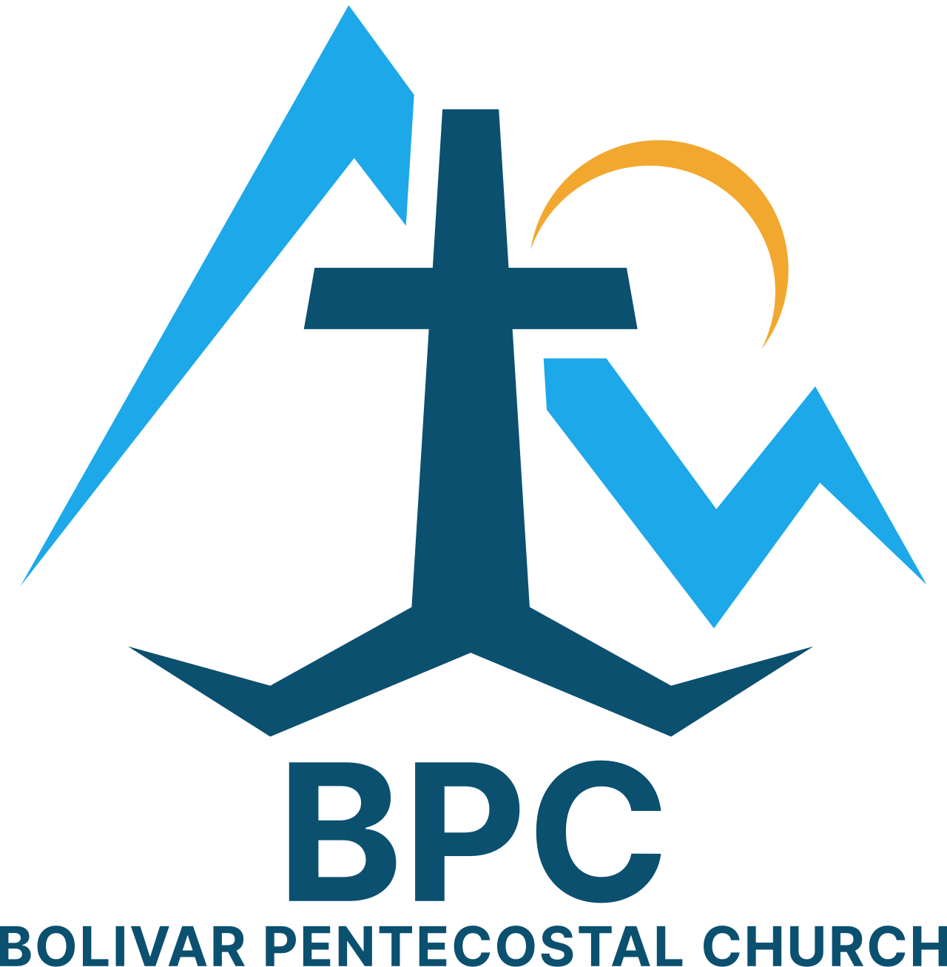 | BPC – Would YOU Help?  ____ OCC shoeboxes for 2026 – would you consider donating some?  ____ Donation towards Building Fund – 1st floor & sanctuary renovations  ____ Get involved in a Life Connection ministry team, if you’re not already | BPC’s Missions & World Evangelism Support – Will YOU Help?  ____ Special offering on Missions Sunday in support of our Missionaries/Evangelists  ____ Special offering to help w/ Sound Of Truth Radio’s radio debt from last Fall  ____ Pray regularly that God would give open doors of ministry to all the Missionaries/Evangelists we support | Special Projects You Can Help With:  ____ Back Offices reorganized, painted & setup  ____ Cleanup in & around garage  ____ Weeding of white rocks around church
“Eye Has Not Seen, Nor Ear Heard, Neither Has Entered Into The Heart Of Man… What God Has In Store!” – I Corinthians 2:9

