October | 2025
Bolivar Pentecostal Church BPCHarpersFerry@gmail.com www.bpcharpersferry.com
Sunday | Monday | Tuesday | Wednesday | Thursday | Friday | Saturday
 |  |  | 1 | 2 | 3 | 4
 |  |  | Prayer Meeting 9am  Midweek Bible Study @ 6:30pm  Youth Service 8pm | Prayer Meeting 9am | Prayer Meeting 9am  Pastor Eric’s Sound Of Truth Radio 12:30am & 1:30pm
MISSIONS SUNDAY 5 | 6 | 7 | 8 | 9 | 10 | 11
PSP @ 9:30am  Sun School 10am  Sun AM Worship 11am  Sun PM Worship 6pm | Prayer Meeting 9am  Christian Skate @ Skate Palace 6:30 – 8:30pm | Prayer Meeting 9am | Prayer Meeting 9am  Midweek Bible Study @ 6:30pm  Youth Service 8pm | Prayer Meeting 9am | *NO Prayer Meeting*  Pastor Eric’s Sound Of Truth Radio 12:30am & 1:30pm
Pastor Appreciation 12 | 13 | 14 | 15 | 16 | 17 | 18
PSP @ 9:30am  Sun School 10am  Sun AM Worship 11am  NO PM SERVICE | Prayer Meeting 9am | Prayer Meeting 9am  BOARD MTG 6PM | Prayer Meeting 9am  Midweek Bible Study @ 6:30pm  Youth Service 8pm | Prayer Meeting 9am  Men’s Fellowship 6:30pm | Prayer Meeting 9am  Pastor Eric’s Sound Of Truth Radio 12:30am & 1:30pm
19 | 20 | 21 | 22 | 23 | 24 | 25
PSP @ 9:30am  Sun School 10am  Sun AM Worship 11am  Sun PM Worship 6pm | Prayer Meeting 9am | Prayer Meeting 9am  ANNA’S HEART 6PM | Prayer Meeting 9am  Midweek Bible Study @ 6:30pm  Youth Service 8pm | Prayer Meeting 9am  Ladies’ Dinner & A Craft | Prayer Meeting 9am  Pastor Eric’s Sound Of Truth Radio 12:30am & 1:30pm
26 | 27 | 28 | 29 | 30 | Light The Night 31
PSP @ 9:30am  Sun School 10am  Sun AM Worship 11am  Sun PM Worship 6pm | Prayer Meeting 9am | Prayer Meeting 9am | Prayer Meeting 9am  Midweek Bible Study @ 6:30pm  Youth Service 8pm | Prayer Meeting 9am | Prayer Meeting 9am  Pastor Eric’s Sound Of Truth Radio 12:30am & 1:30pm
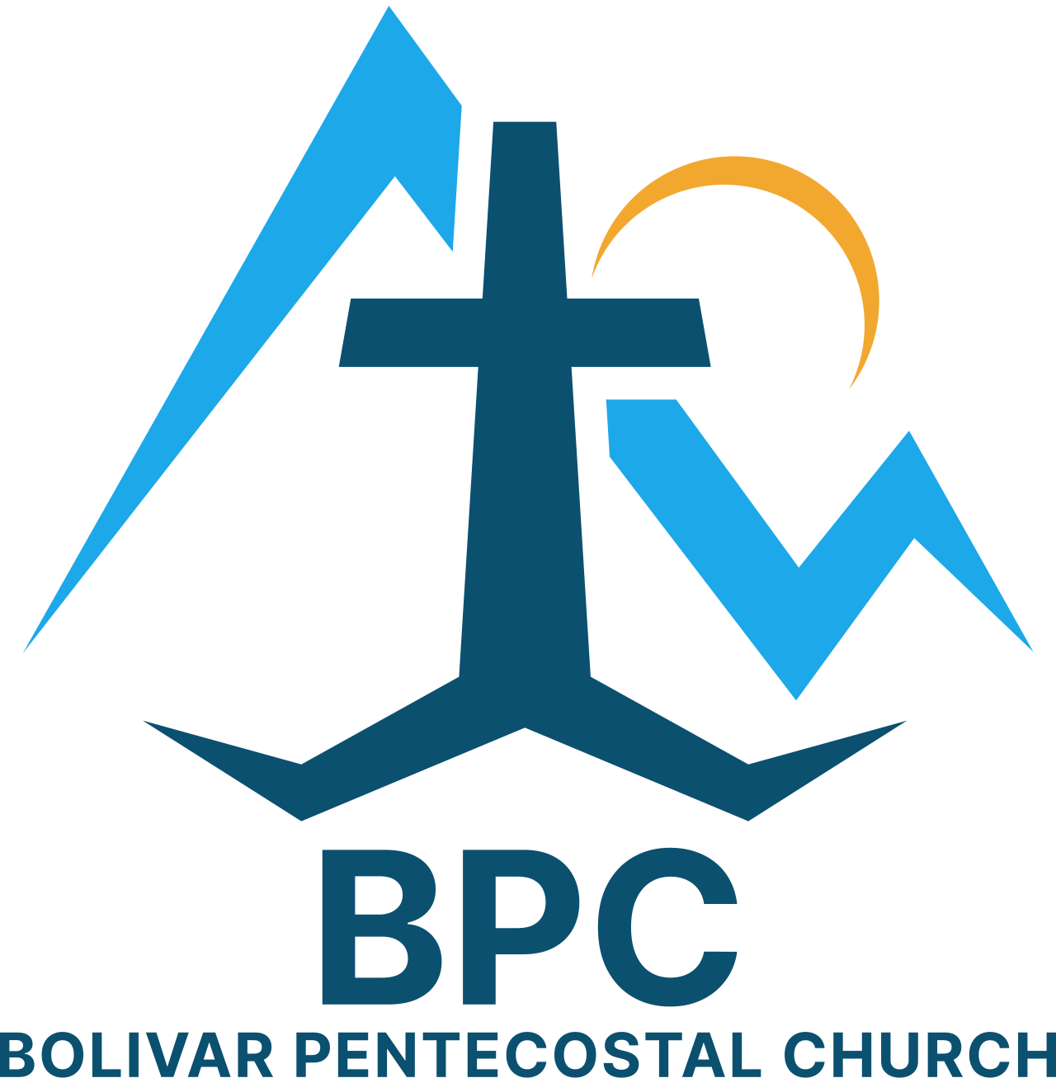 | BPC – Would YOU Help?  ____ OCC shoeboxes for 2025 – would you consider donating some?  ____ Help w/ praise & worship team lyric & sheet music filing  ____ Light The Night community outreach 10/31 – we need volunteers – see Becky Hopkins | BPC’s Missions & World Evangelism Support – Will YOU Help?  ____ Special offering on Missions Sunday in support of our Missionaries/Evangelists  ____ Pray regularly that God would give open doors of ministry to all the Missionaries/Evangelists we support | Special Projects You Can Help With:  ____ Kid’s Church big room clean-up & re-organizing  ____ Back Offices reorganized & bookshelves taken down
“Eye Has Not Seen, Nor Ear Heard, Neither Has Entered Into The Heart Of Man… What God Has In Store!” – I Corinthians 2:9

