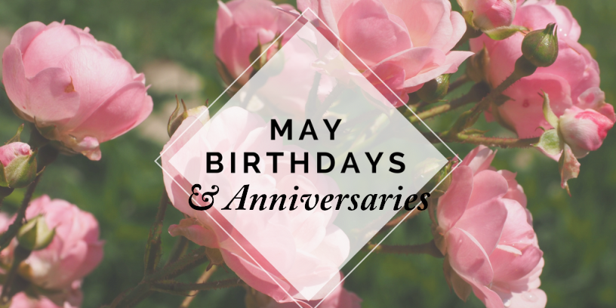
Full Name Date of Birth
Steve Hopkins 5/1
Donna Turner 5/1
James Hudmon 5/6
Jodi Bailey 5/7
Patience Park 5/7
Elliott Smith (child) 5/12
Lynne Pope 5/17
Pastor Eric 5/19
Bettie Hoffman 5/23

Full Name Anniversary Date
Jeff & Karen D’Angelo 5/23

I John 5:14, 15 – “And this is the confidence that we have in Him, that, if we ask any thing according to His will, He hears us: & if we know that He hear us, whatsoever we ask, we know that we have the petitions that we desired of Him.”


