March | 2026
Bolivar Pentecostal Church BPCHarpersFerry@gmail.com www.bpcharpersferry.com
Sunday | Monday | Tuesday | Wednesday | Thursday | Friday | Saturday
MISSIONS SUNDAY 1 | 2 | 3 | 4 | 5 | 6 | 7
PSP @ 9:30am  Sun School 10am  Sun AM Worship 11am  CHILI COOKOFF – NO PM | Prayer Meeting 9am  Christian Skate Night 6:30pm – 8:30pm | Prayer Meeting 9am | Prayer Meeting 9am  Midweek Bible Study @ 6:30pm  Youth Service 8pm | Prayer Meeting 9am  Wanda Depfer’s Funeral @ Eackles 11am | Prayer Meeting 9am  Pastor Eric’s Sound Of Truth Radio 12:30am & 1:30pm
8 | 9 | 10 | 11 | 12 | 13 | 14
PSP @ 9:30am  Sun School 10am  Refuel Prayer, Praise & Communion 11am  Sun PM Worship 6pm | Prayer Meeting 9am | Prayer Meeting 9am  BOARD MEETING 6PM | Prayer Meeting 9am  Midweek Bible Study @ 6:30pm  Youth Service 8pm | Prayer Meeting 9am | Pastor Eric’s Sound Of Truth Radio 12:30am & 1:30pm  Bob Cornell 7pm | Bob Cornell 9:30am – Breakfast & Teaching  7pm Service
15 | 16 | 17 | 18 | 19 | 20 | 21
PSP @ 9:30am  Sun School 10am  Bob Cornell 11am  NO PM SERVICE | Prayer Meeting 9am | Prayer Meeting 9am  ANNA’S HEART 6PM | Prayer Meeting 9am  Midweek Bible Study @ 6:30pm  Youth Service 8pm | Prayer Meeting 9am  Men’s Fellowship 6:30pm | Prayer Meeting 9am  Pastor Eric’s Sound Of Truth Radio 12:30am & 1:30pm
22 | 23 | 24 | 25 | 26 | 27 | 28
PSP @ 9:30am  Sun School 10am  Sun AM Worship 11am  Sun PM Worship 6pm | Prayer Meeting 9am | Prayer Meeting 9am | Prayer Meeting 9am  Midweek Bible Study @ 6:30pm  Youth Service 8pm | Prayer Meeting 9am | Prayer Meeting 9am  Pastor Eric’s Sound Of Truth Radio 12:30am & 1:30pm | Easter Neighborhood invites 10am
29 | 30 | 31
PSP @ 9:30am  Sun School 10am  Sun AM Worship 11am  Sun PM Worship 6pm | Prayer Meeting 9am | Prayer Meeting 9am
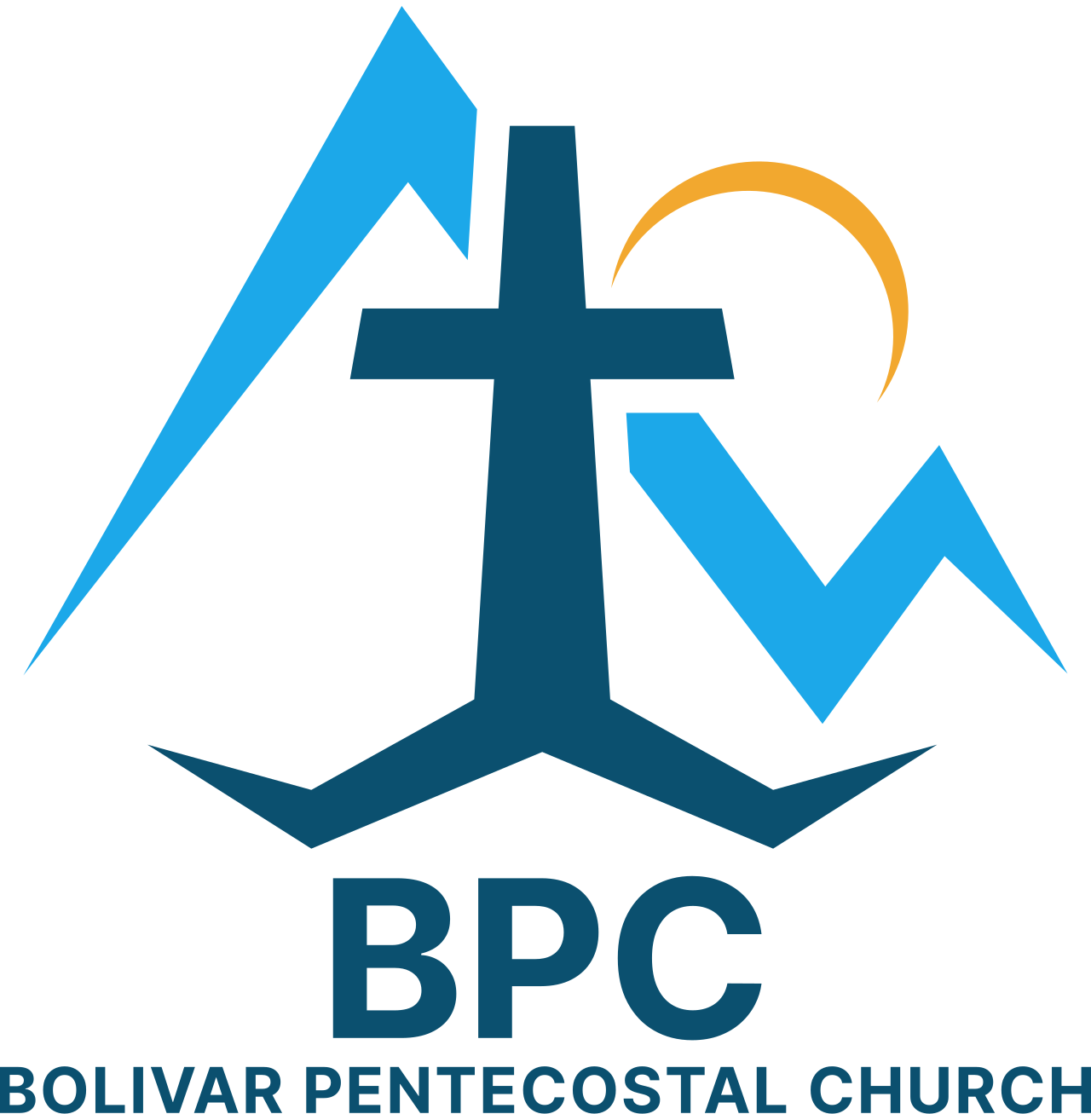 | BPC – Would YOU Help?  ____ OCC shoeboxes for 2026 – would you consider donating some?  ____ Donation towards Building Fund – 1st floor & sanctuary renovations  ____ Get involved in a Life Connection ministry team, if you’re not already | BPC’s Missions & World Evangelism Support – Will YOU Help?  ____ Special offering on Missions Sunday in support of our Missionaries/Evangelists  ____ Pray regularly that God would give open doors of ministry to all the Missionaries/Evangelists we support | Special Projects You Can Help With:  ____ Kid’s Church big room clean-up & re-organizing  ____ Back Offices reorganized, painted & setup  ____ Cleanup in & around garage
“Eye Has Not Seen, Nor Ear Heard, Neither Has Entered Into The Heart Of Man… What God Has In Store!” – I Corinthians 2:9

