October | 2026
Bolivar Pentecostal Church BPCHarpersFerry@gmail.com www.bpcharpersferry.com
Sunday | Monday | Tuesday | Wednesday | Thursday | Friday | Saturday
 |  |  |  | Prayer Mtg 9am 1 | Prayer Mtg 9am 2 | 3
 |  |  |  | Ladies’ Bible Study @ 6:30pm | Pastor Eric’s Sound Of Truth Radio 12:30am & 1:30pm
MISSIONS SUNDAY 4 | 5 | 6 | 7 | 8 | 9 | 10
PSP @ 9:30am  Sun School 10am  OCC BAKE SALE  REFUEL SERVICE 11am  Sun PM Worship 6pm | Prayer Meeting 9am | Prayer Meeting 9am | Prayer Meeting 9am  Midweek Bible Study & Youth Service @ 6:30pm | Prayer Meeting 9am  Ladies’ Bible Study @ 6:30pm | Prayer Meeting 9am  Pastor Eric’s Sound Of Truth Radio 12:30am & 1:30pm
11 | 12 | 13 | 14 | 15 | 16 | 17
PSP @ 9:30am  Sun School 10am  Sun AM Worship 11am  Sun PM Worship 6pm | Prayer Meeting 9am | Prayer Meeting 9am  Board Meeting @ 6pm | Prayer Meeting 9am  Midweek Bible Study & Youth Service @ 6:30pm | Prayer Meeting 9am  Men’s Fellowship & Ladies’ Bible Study @ 6:30pm | Prayer Meeting 9am  Pastor Eric’s Sound Of Truth Radio 12:30am & 1:30pm
Pastor’s 18 | 19 | 20 | 21 | 22 | 23 | 24
Appreciation  PSP @ 9:30am  Sun School 10am  Sun AM Worship 11am  *NO PM SERVICE* | Prayer Meeting 9am | Prayer Meeting 9am  ANNA’S HEART 6PM | Prayer Meeting 9am  Midweek Bible Study & Youth Service @ 6:30pm | Prayer Meeting 9am  Ladies’ Bible Study @ 6:30pm | Prayer Meeting 9am  Pastor Eric’s Sound Of Truth Radio 12:30am & 1:30pm
25 | 26 | 27 | 28 | 29 | 30 | 31
PSP @ 9:30am  Sun School 10am  Sun AM Worship 11am  Sun PM Worship 6pm | Prayer Meeting 9am | Prayer Meeting 9am | Prayer Meeting 9am  Midweek Bible Study & Youth @ 6:30pm | Prayer Meeting 9am  Ladies’ Bible Study @ 6:30pm | Prayer Meeting 9am  Pastor Eric’s Sound Of Truth Radio 12:30am & 1:30pm | Happy Reformation Day!  “The Just Shall Live By Faith!”
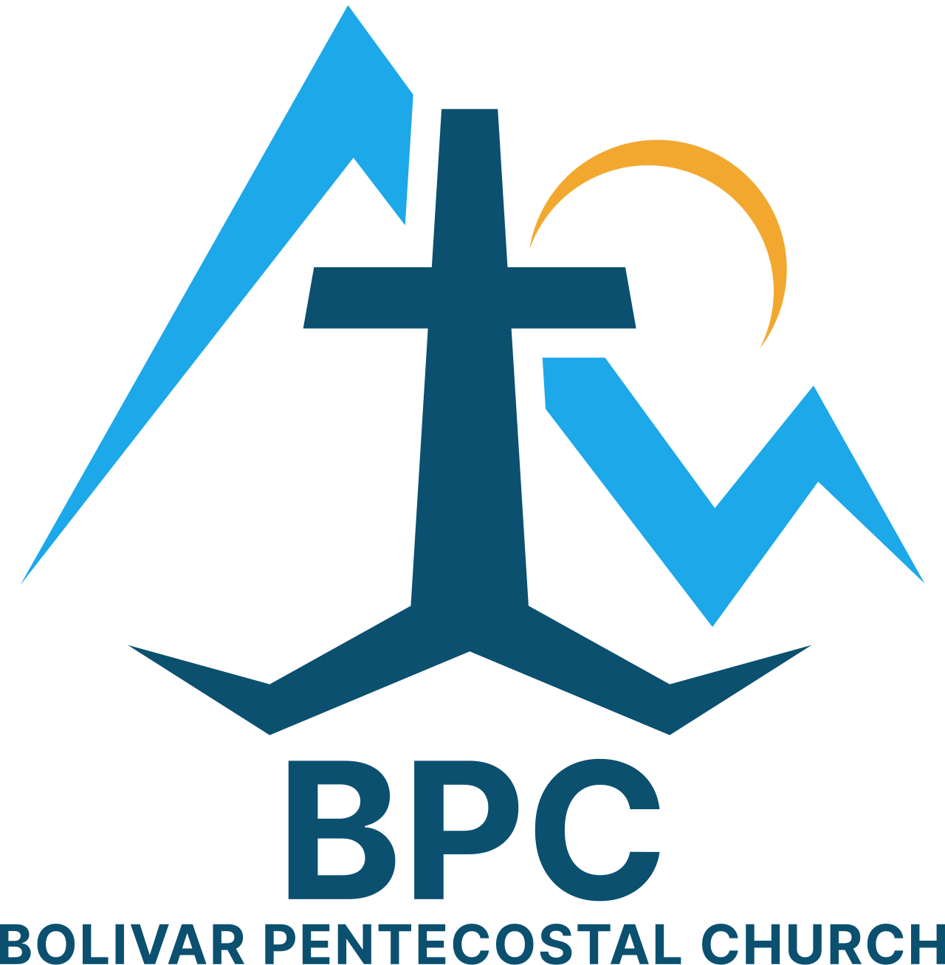 | BPC – Would YOU Help?  ____ OCC shoeboxes for 2026 – would you consider donating some?  ____ Donation towards Building Fund – 1st floor & sanctuary renovations  ____ Get involved in a Life Connection ministry team, if you’re not already | BPC’s Missions & World Evangelism Support – Will YOU Help?  ____ Special offering on Missions Sunday in support of our Missionaries/Evangelists  ____ Special offering to help w/ Sound Of Truth Radio’s radio debt from last Fall  ____ Pray regularly that God would give open doors of ministry to all the Missionaries/Evangelists we support | Special Projects You Can Help With:  ____ Back Offices reorganized, painted & setup  ____ Cleanup in & around garage  ____ Weeding of white rocks around church
“Eye Has Not Seen, Nor Ear Heard, Neither Has Entered Into The Heart Of Man… What God Has In Store!” – I Corinthians 2:9

