December | 2025
Bolivar Pentecostal Church BPCHarpersFerry@gmail.com www.bpcharpersferry.com
Sunday | Monday | Tuesday | Wednesday | Thursday | Friday | Saturday
 | 1 | 2 | 3 | 4 | Prayer Mtg 9am 5 | 6
 | Prayer Meeting 9am  Christian Skate @ Skate Palace 6:30 – 8:30pm | Prayer Meeting 9am | Prayer Meeting 9am  Midweek Bible Study @ 6:30pm  Youth Service 8pm | Prayer Meeting 9am | Pastor Eric’s Sound Of Truth Radio 12:30am & 1:30pm  Ladies Dinner & Craft 6pm | Joseph Larson 11am  Richmond, VA
MISSIONS SUNDAY 7 | 8 | 9 | 10 | 11 | 12 | 13
PSP @ 9:30am  Sun School 10am  Sun AM Worship 11am  Sun PM Worship 6pm | Prayer Meeting 9am  Pastor & Board Christmas Party 6pm | Prayer Meeting 9am | Prayer Meeting 9am  Midweek Bible Study @ 6:30pm  Youth Service 8pm | Prayer Meeting 9am | Prayer Meeting 9am  Pastor Eric’s Sound Of Truth Radio 12:30am & 1:30pm
Christmas Banquet 14 | 15 | 16 | Prayer Mtg 9am 17 | 18 | 19 | 20
PSP @ 9:30am  Sun School 10am  Sun AM Worship 11am  *NO PM SERVICE* | Prayer Meeting 9am | Prayer Meeting 9am  ANNA’S HEART 6PM | Midweek Bible Study @ 6:30pm  Youth Christmas Party 8pm | Prayer Meeting 9am  Men’s Fellowship 6:30pm | Prayer Meeting 9am  Pastor Eric’s Sound Of Truth Radio 12:30am & 1:30pm
Christmas Celebration 21 | 22 | 23 | 24 | 25 | 26 | 27
PSP @ 9:30am  Sun School 10am  Sun AM Worship 11am  *NO PM SERVICE* | Prayer Meeting 9am | Prayer Meeting 9am | *NO Prayer Meeting* Chistmas Eve Candlelight Service 5pm | *NO Prayer Meeting*  Merry Christmas! | *NO Prayer Meeting*  Pastor Eric’s Sound Of Truth Radio 12:30am & 1:30pm
28 | 29 | 30 | 31
PSP @ 9:30am  Sun School 10am  Sun AM Refuel Service  *NO PM SERVICE* | Prayer Meeting 9am | Prayer Meeting 9am | *NO Prayer Meeting*  ***NO SERVICES***  New Year’s Eve
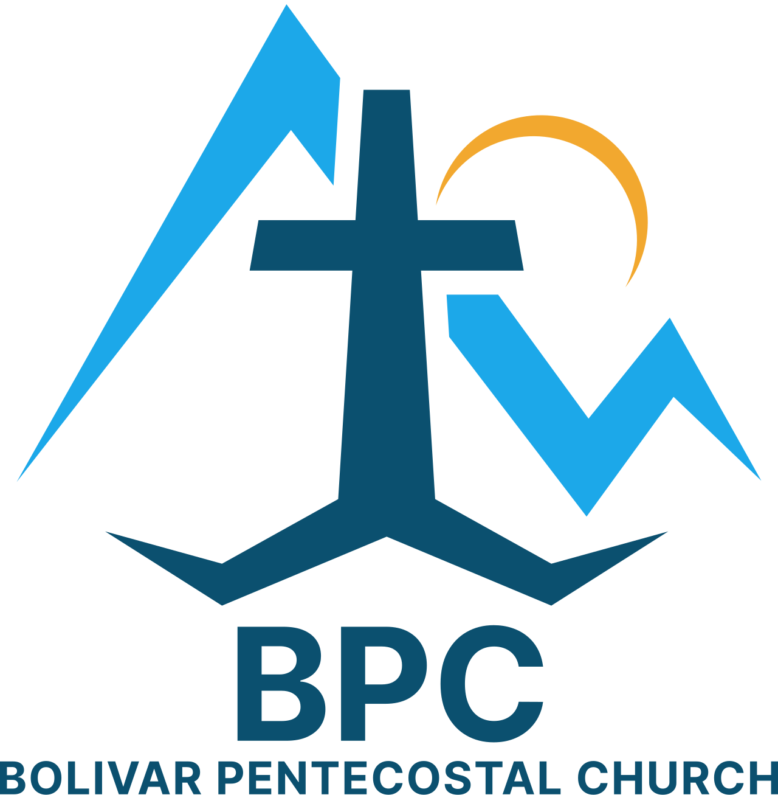 | BPC – Would YOU Help?  ____ Come & be a part of our annual Christmas Banquet on 12/14 after the 11am service  ____ Invite some people to our Christmas Celebration on 12/21  ____ Invite some people to our Christmas Eve Candlelight Service | BPC’s Missions & World Evangelism Support – Will YOU Help?  ____ Special offering on Missions Sunday in support of our Missionaries/Evangelists  ____ Pray regularly that God would give open doors of ministry to all the Missionaries/Evangelists we support  ____ Ask the Lord what HE would have you give in 2026 monthly towards Missions & fill out a Faith Promise slip | Special Projects You Can Help With:  ____ Kid’s Church big room clean-up & re-organizing  ____ Back Offices painted & setup
“Eye Has Not Seen, Nor Ear Heard, Neither Has Entered Into The Heart Of Man… What God Has In Store!” – I Corinthians 2:9

