January | 2026
Bolivar Pentecostal Church BPCHarpersFerry@gmail.com www.bpcharpersferry.com
Sunday | Monday | Tuesday | Wednesday | Thursday | Friday | Saturday
 |  |  |  | 1 | 2 | 3
 |  |  |  | *NO Prayer Mg *  Happy New Year! | Prayer Meeting 9am  Pastor Eric’s Sound Of Truth Radio 12:30am & 1:30pm
MISSIONS SUNDAY 4 | 5 | 6 | 7 | 8 | 9 | 10
PSP @ 9:30am  Sun School 10am  Sun AM Worship 11am  Sun PM Worship 6pm | Prayer Meeting 9am  Christian Skate @ Skate Palace 6:30 – 8:30pm | Prayer Meeting 9am | Prayer Meeting 9am  Midweek Bible Study @ 6:30pm  Youth Service 8pm | Prayer Meeting 9am | Prayer Meeting 9am  Pastor Eric’s Sound Of Truth Radio 12:30am & 1:30pm
11 | 12 | 13 | Prayer Mtg 9am 14 | 15 | *NO Prayer Mg * 16 | 17
PSP @ 9:30am  Sun School 10am  Sun AM Worship 11am  Sun PM Worship 6pm | Prayer Meeting 9am | Prayer Meeting 9am  BOARD MTG 6PM | *NO Prayer Mg *  Midweek Bible Study @ 6:30pm  Youth Service 8pm | *NO Prayer Mg *  Men’s Fellowship 6:30pm | Pastor Eric’s Sound Of Truth Radio 12:30am & 1:30pm  Ladies’ Dinner & Movie
18 | 19 | 20 | 21 | 22 | 23 | 24
PSP @ 9:30am  Sun School 10am  Sun AM Worship 11am  Sun PM Worship 6pm | Prayer Meeting 9am | *NO Prayer Mg *  ANNA’S HEART 6PM | *NO Prayer Mg *  Midweek Bible Study @ 6:30pm  *NO Youth Service* | *NO Prayer Mg * | *NO Prayer Mg *  Pastor Eric’s Sound Of Truth Radio 12:30am & 1:30pm
25 | 26 | 27 | 28 | 29 | 30 | 31
PSP @ 9:30am  Sun School 10am  Sun AM Worship 11am  *NO Sun PM Worship* | *NO Prayer Mg * | *NO Prayer Mg * | Prayer Meeting 9am  Midweek Bible Study @ 6:30pm  Youth Service 8pm | Prayer Meeting 9am | Prayer Meeting 9am  Pastor Eric’s Sound Of Truth Radio 12:30am & 1:30pm
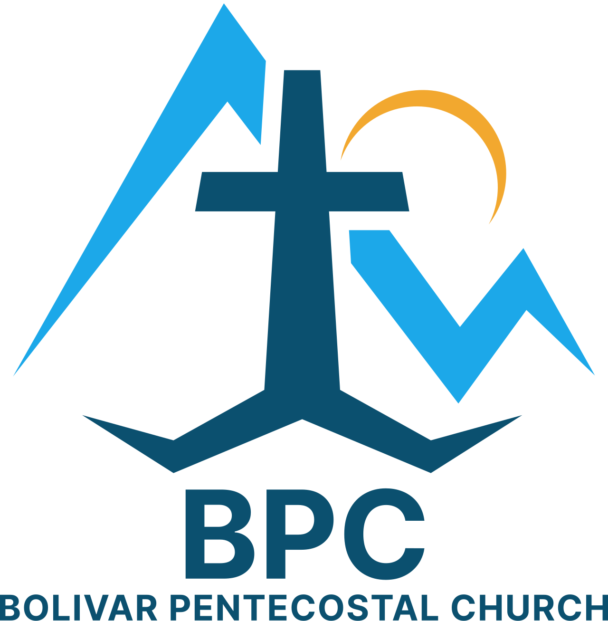 | BPC – Would YOU Help?  ____ Recommit to being in Church Sun AM & PM, & Wed PM  ____ Sign-up & get involved in a Life Connection ministry @ BPC  ____ Invite a family member, co-worker &/or friend to come to church w/ you this month  ____ Recommit to times of corporate prayer @ BPC – James 5:16 | BPC’s Missions & World Evangelism Support – Will YOU Help?  ____ Special offering on Missions Sunday in support of our Missionaries/Evangelists  ____ Pray regularly that God would give open doors of ministry to all the Missionaries/Evangelists we support  ____ Be faithful in giving your monthly Faith Promise | Special Projects You Can Help With:  ____ Kid’s Church big room clean-up & re-organizing  ____ Back Offices painted & setup  ____ Donate Expositor’s Study Bibles for sanctuary & outreach - $15 each
“Eye Has Not Seen, Nor Ear Heard, Neither Has Entered Into The Heart Of Man… What God Has In Store!” – I Corinthians 2:9

