May | 2024
Bolivar Pentecostal Church BPCHarpersFerry@gmail.com www.bpcharpersferry.com
Sunday | Monday | Tuesday | Wednesday | Thursday | Friday | Saturday
 |  |  | 1 | 2 | 3 | 4
 |  |  | Book Of Acts Midweek Bible Study & Youth Pizza & Discipleship 6:30pm | P&W Team Practice @ 6:30pm | Pastor Eric’s Sound Of Truth Radio 12:30am & 1:30pm
MISSIONS SUNDAY 5 | 6 | 7 | ***NO SERVICES*** 8 | 9 | 10 | 11
PSP @ 9:30am  Sun School 10am  Sun AM Worship 11am Sun PM Worship 6pm |  | Prayer Meeting @ 9am  Youth Service 6:30pm | BPC ANNUAL BUSINESS MEETING 6:30PM | P&W Team Practice @ 6:30pm | Pastor Eric’s Sound Of Truth Radio 12:30am & 1:30pm
Mother’s Day 12 | 13 | 14 | 15 | 16 | 17 | 18
PSP @ 9:30am  Sun School 10am  Sun AM Worship 11am  ***NO SUN PM*** |  | Prayer Meeting @ 9am  Youth Service 6:30pm | Book Of Acts Midweek Bible Study & Youth Pizza & Discipleship 6:30pm | P&W Team Practice @ 6:30pm  Men’s Fellowship 6:30pm | Pastor Eric’s Sound Of Truth Radio 12:30am & 1:30pm | Harpers Ferry 5K & Half-Marathon  Outreach
Pentecost Sunday 19 | 20 | 21 | 22 | 23 | 24 | 25
OCC BAKE SALE  PSP @ 9:30am  Sun School 10am  Sun AM Worship 11am Sun PM Worship 6pm |  | Prayer Meeting @ 9am  Youth Service 6:30pm  ANNA’S HEART 6PM | Book Of Acts Midweek Bible Study & Youth Pizza & Discipleship 6:30pm | P&W Team Practice @ 6:30pm | Pastor Eric’s Sound Of Truth Radio 12:30am & 1:30pm
26 | 27 | 28 | Book Of Acts 29 | 30 | 31
PSP @ 9:30am  Sun School 10am  Sun AM Worship 11am  ***NO SUN PM*** |  | Prayer Meeting @ 9am  Youth Service 6:30pm | Midweek Bible Study & Youth Pizza & Discipleship 6:30pm | P&W Team Practice @ 6:30pm | Pastor Eric’s Sound Of Truth Radio 12:30am & 1:30pm
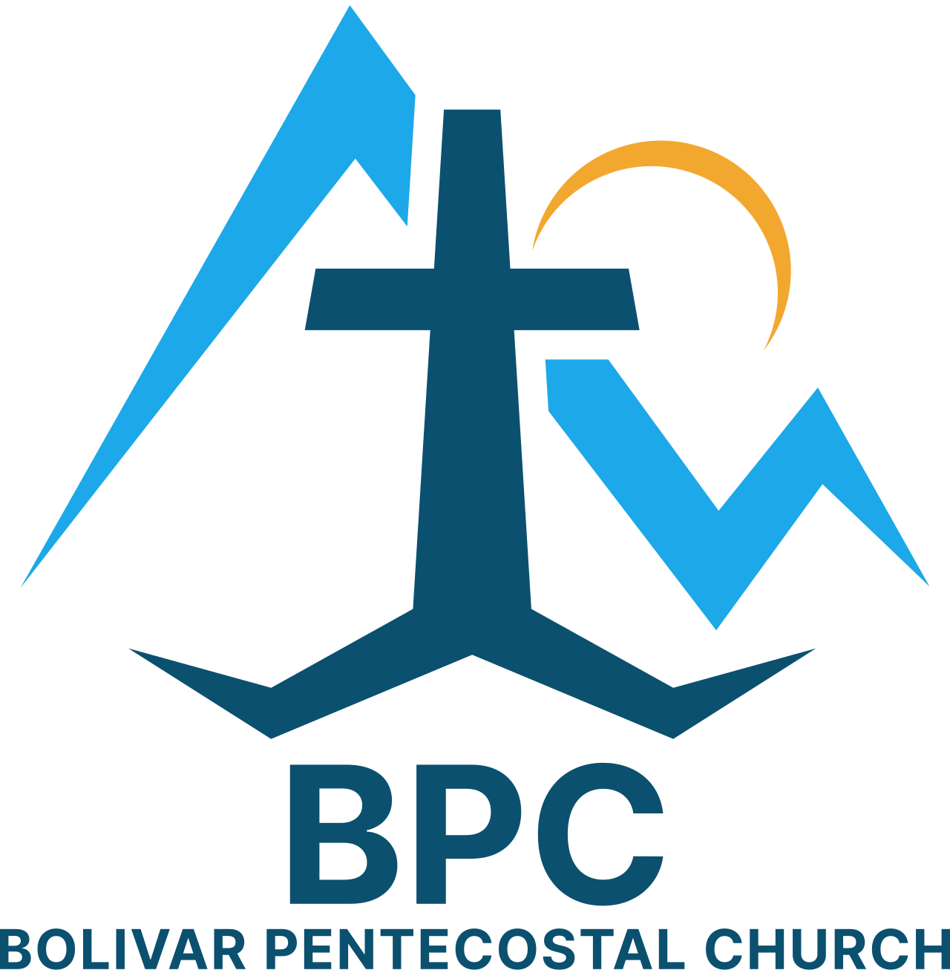 | BPC – Would YOU Help?  ____ Donations of food for Community Food Bank  ____ OCC shoeboxes – would you consider donating some?  ____ Donation towards 2 Youth Camps this July | BPC’s Missions & World Evangelism Support – Will YOU Help?  ____ Special offering on Missions Sunday in support of our Missionaries/Evangelists  ____ Pray regularly that God would give open doors of ministry to all the Missionaries/Evangelists we support | Special Projects You Can Help With:  ____ Organizing back office spaces  ____ Moving of at least 2 filling cabinets upstairs near Pastor Eric’s office  ____ Kid’s Church big room clean-up & re-organizing  ____ Weeds sprayed &/or pulled in white stones around church building  ____ Hedges trimmed around church
“Eye Has Not Seen, Nor Ear Heard, Neither Has Entered Into The Heart Of Man… What God Has In Store!” – I Corinthians 2:9

