May | 2026
Bolivar Pentecostal Church BPCHarpersFerry@gmail.com www.bpcharpersferry.com
Sunday | Monday | Tuesday | Wednesday | Thursday | Friday | Saturday
 |  |  |  |  | 1 | 2
Prayer Meeting 9am
Pastor Eric’s Sound Of Truth Radio 12:30am & 1:30pm
MISSIONS SUNDAY 3 | 4 | 5 | 6 | 7 | 8 | 9
PSP @ 9:30am  Sun School 10am  Sun AM Worship 11am  Sun PM Worship 6pm | *NO Prayer Meeting* | *NO Prayer Meeting* | *NO Prayer Meeting*  Midweek Bible Study @ 6:30pm  *NO Youth Service* | *NO Prayer Meeting* | *NO Prayer Meeting*  Pastor Eric’s Sound Of Truth Radio 12:30am & 1:30pm | Zoe Harding’s Graduation in Baton Rouge, LA
Mother’s Day 10 | 11 | 12 | 13 | 14 | 15 | Harpers Ferry 5K 16
Sun School 10am  Sun AM Worship 11am  *NO PM WORSHIP* | *NO Prayer Meeting* | Prayer Meeting 9am | Prayer Meeting 9am  BPC Annual Business Meeting @ 6:30pm | Prayer Meeting 9am | Prayer Meeting 9am  Pastor Eric’s Sound Of Truth Radio 12:30am & 1:30pm | & Half Outreach  OCC Trip To Shippensburg
Graduation Sun 17 | 18 | 19 | 20 | 21 | 22 | 23
PSP @ 9:30am  Sun School 10am  Sun AM Worship 11am  Graduation Lunch  *NO PM Worship* | Prayer Meeting 9am | Prayer Meeting 9am  ANNA’S HEART 6PM | Prayer Meeting 9am  Midweek Bible Study @ 6:30pm  Youth Service 8pm | Prayer Meeting 9am  Men’s Fellowship 6:30pm | Prayer Meeting 9am  Pastor Eric’s Sound Of Truth Radio 12:30am & 1:30pm | Youth Bike Ride Fundraiser
24/31 | Memorial Day 25 | 26 | Prayer Mtg 9am 27 | 28 | 29 | 30
PSP @ 9:30am  Sun School 10am  Sun AM Worship 11am  *NO PM Worship* | *NO Prayer Meeting* | Prayer Meeting 9am | Midweek Bible Study @ 6:30pm  Youth Service 8pm | Prayer Meeting 9am  Women’s Dinner @ 6:30pm | Prayer Meeting 9am  Pastor Eric’s Sound Of Truth Radio 12:30am & 1:30pm
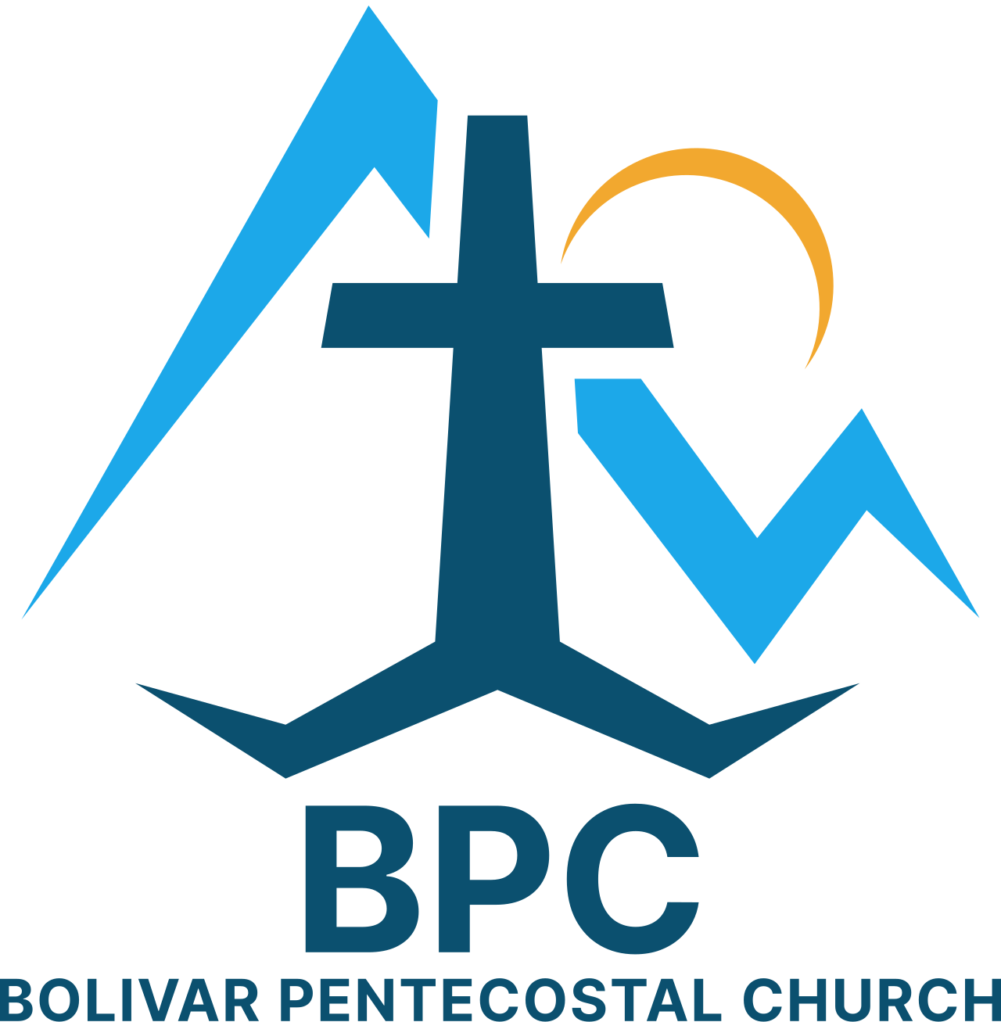 | BPC – Would YOU Help?  ____ OCC shoeboxes for 2026 – would you consider donating some?  ____ Donation towards Building Fund – 1st floor & sanctuary renovations  ____ Get involved in a Life Connection ministry team, if you’re not already | BPC’s Missions & World Evangelism Support – Will YOU Help?  ____ Special offering on Missions Sunday in support of our Missionaries/Evangelists  ____ Pray regularly that God would give open doors of ministry to all the Missionaries/Evangelists we support | Special Projects You Can Help With:  ____ Kid’s Church big room clean-up & re-organizing  ____ Back Offices reorganized, painted & setup  ____ Cleanup in & around garage
“Eye Has Not Seen, Nor Ear Heard, Neither Has Entered Into The Heart Of Man… What God Has In Store!” – I Corinthians 2:9

